**Host name creation**

**Steps:**

1. Go to host file location

**“C:\Windows\System32\drivers\etc”**

1. Open the “hosts” file and provide the desired value to against location host ip as shown below.

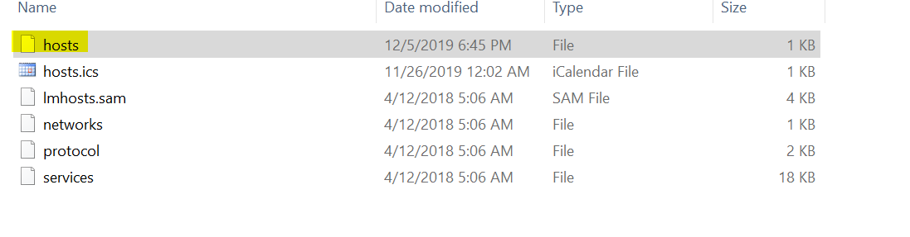

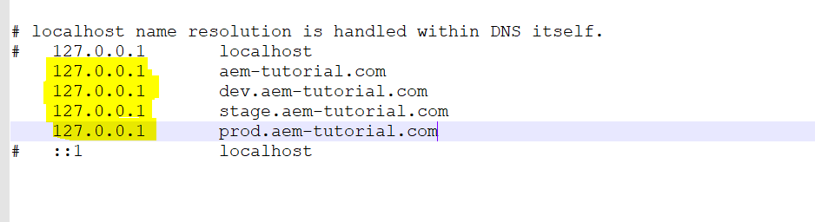

1. In the above screenshot, different values were provided against the local ip address, so the local instance can now be accessed via these custom names given.

